S3 Bucket Task

1. Create an S3 bucket and upload some objects to S3
Create a bucket from S3 dashboard, with ACL enabled and Bucket versioning enabled
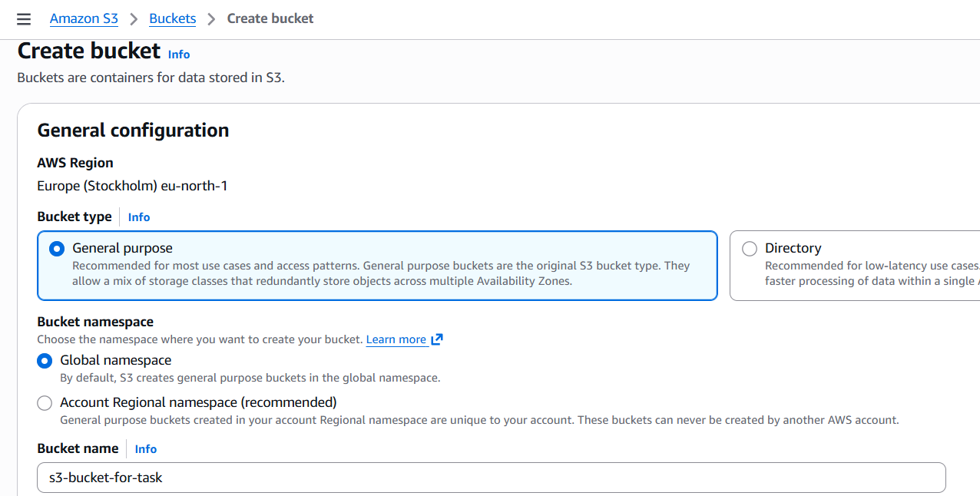
Upload 2 files
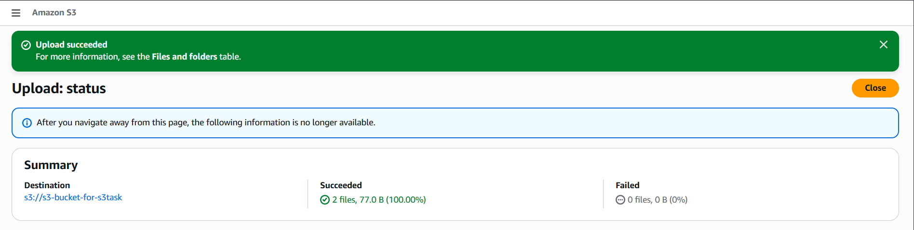

2. Deploy a static website in the S3 bucket
After the 1’st task we have 2 files now, So to deploy that we should give permission using ACL, as it is shown below to open it using the object URL
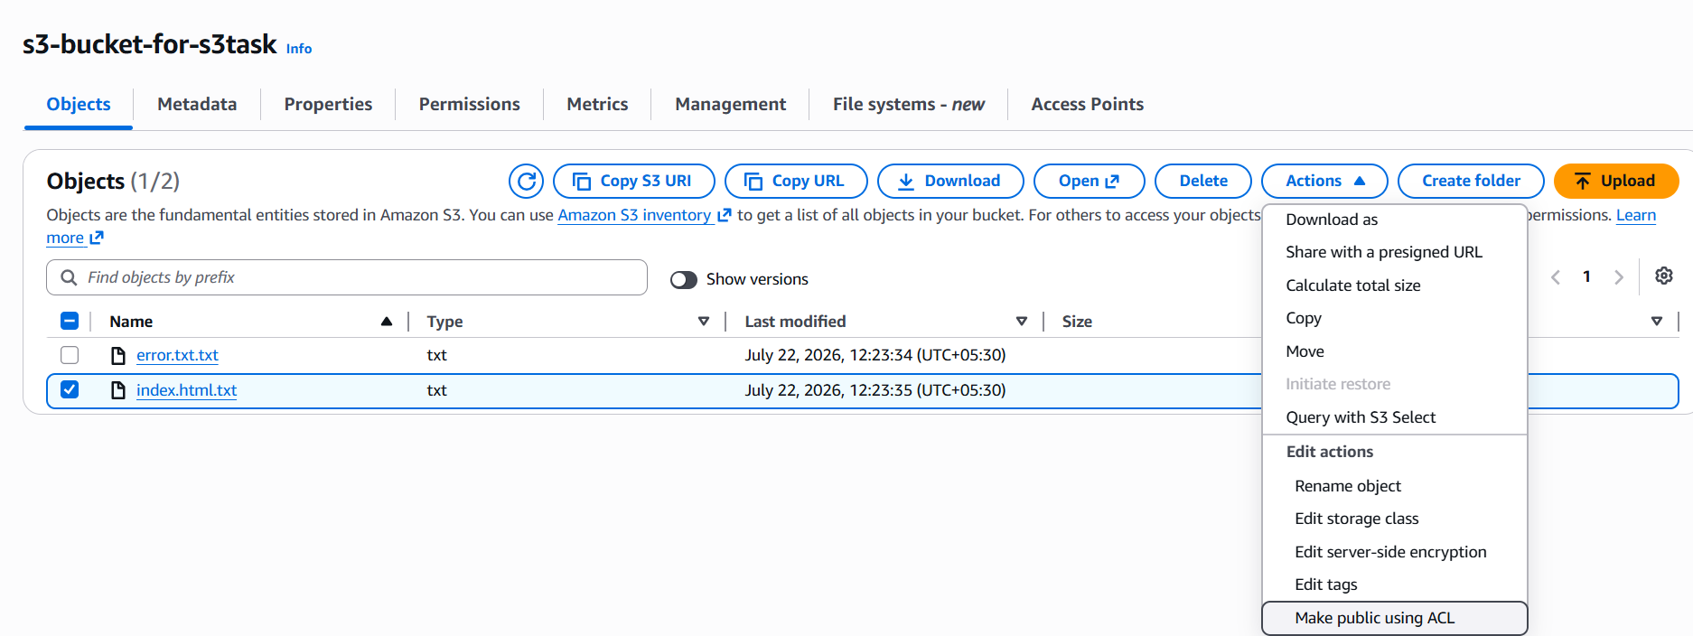
Once it is given, It is deployed and it works
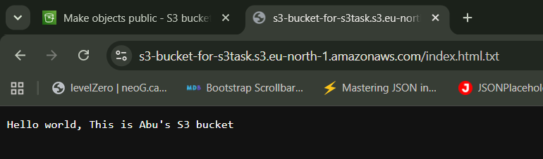

3. Enable cross-region replication on S3 buckets
Create 2 buckets from different region
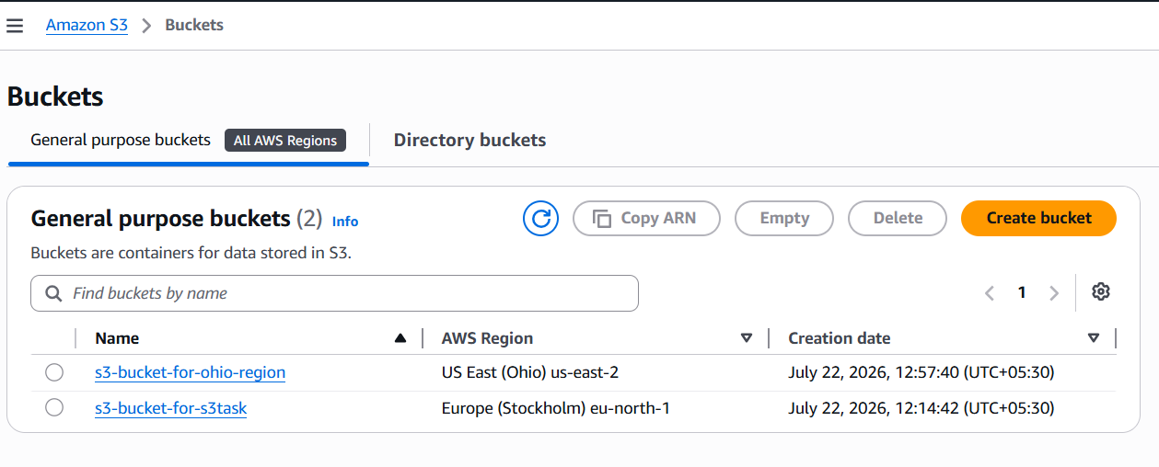
Configure the replication rules
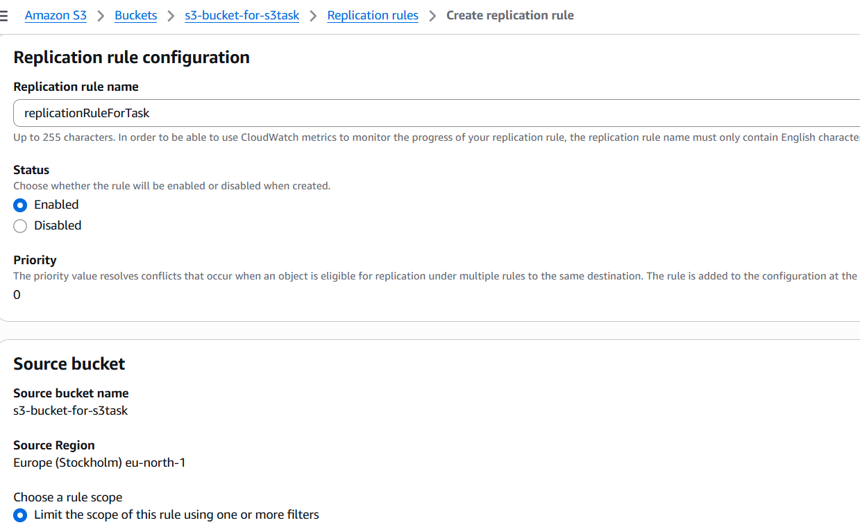
Once it is created, upload a new file In the source
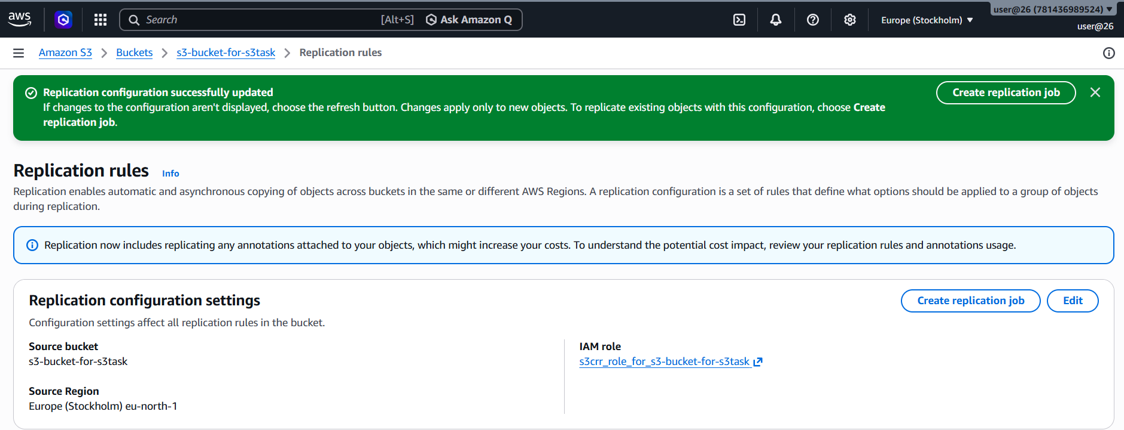
And to make sure the status, you can check the Replication rules status
As you can see the file got uploaded in Europe region
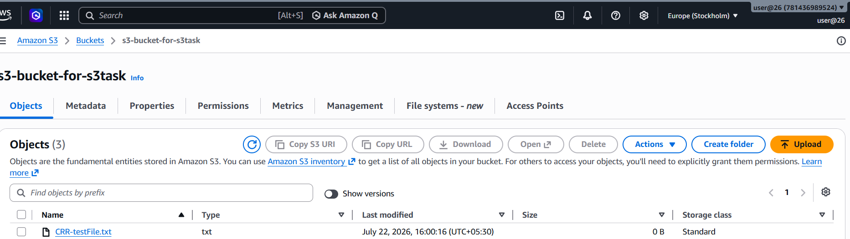
And it is replicated to that other region as well in Ohio region
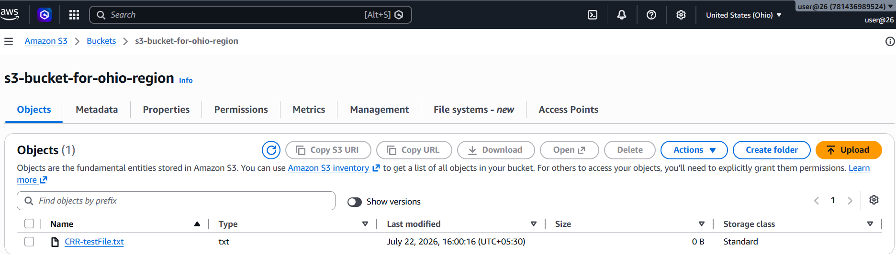

4. Configure a bucket policy so only the Admin user can see the objects of the S3 bucket
Find the Admin User ARN and open the S3 Bucket
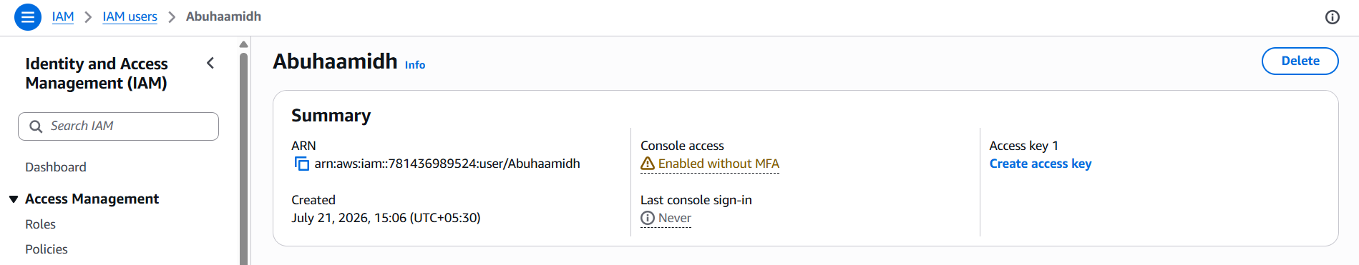
Open the bucket policy and make the changes accordingly with our ARN number and bucket name

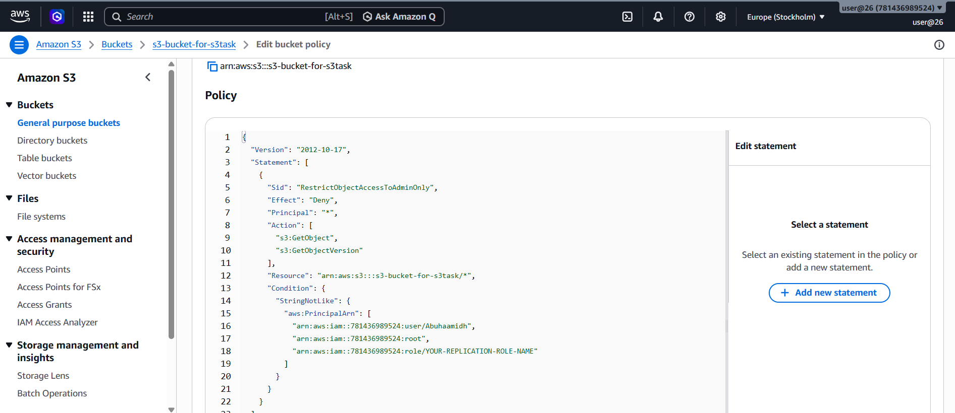
Log in as the Admin user and open the bucket
You should be able to -
View the bucket, List the objects and Download objects
A different IAM user without permission unable to access the bucket.

5. Set up lifecycle policies to automatically transition or delete objects based on specific criteria
Login to management console
And you can click on create lifecycle rules
Give name, scope, Apply all objects
Transition Objects (Move to a Lower-Cost Storage Class)
Select on Transition current versions of objects between storage classes
Below you can give After: 30 Days
Select on Expire (Delete) Objects
Expire current versions of objects
Enter delete after: 365 Days
AWS will automatically delete the objects after 365 days.
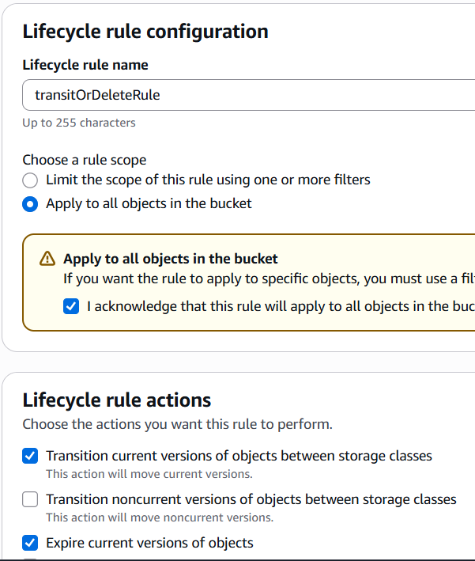
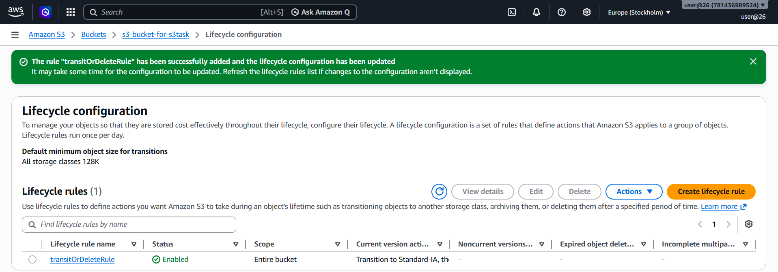
You can verify it, and it is shown above
Suppose you upload a file today.
File.txt
AWS automatically performs the following actions:
Day 1
File.txt
│
Day 30
Moved to Standard-IA
│
Day 90
Moved to Glacier
│
Day 365
It gets Deleted

6. Push some objects to S3 using the AWS CLI
First we need to check the version using aws –version
Then configure it using aws configure
Create an access key in security credentials from management console
And enter the required details which is needed
Then I have a file name aws-task.pem file and I copied It using cp <File name>s3://<bucket name>
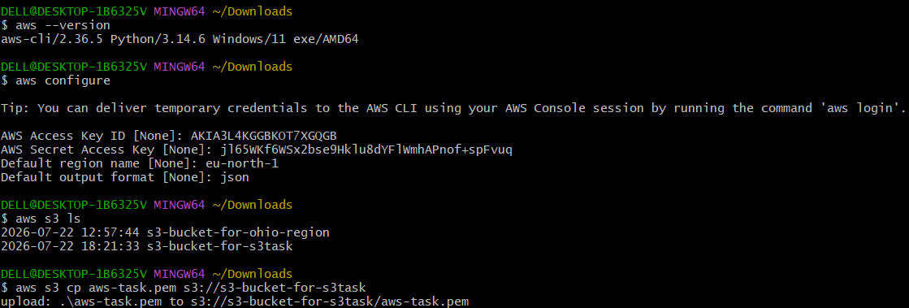
And you can see here, I just verified it in the console, the file has been pushed
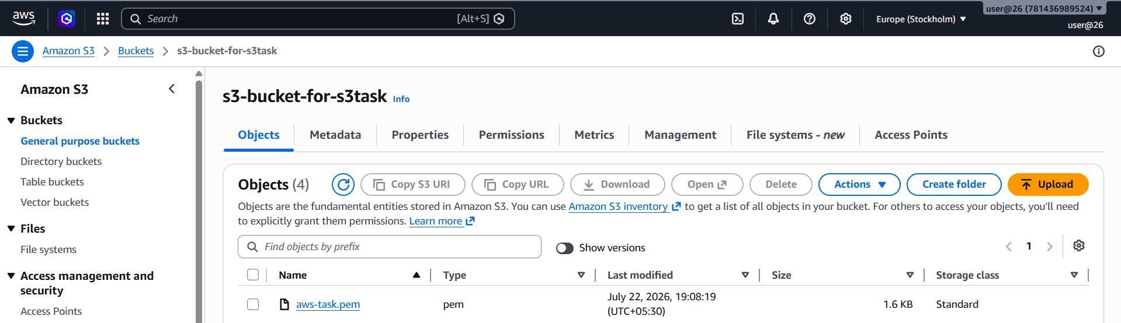

7. Write a Bash script to create an S3 bucket
Create a bash script file and write the bash script for creating a s3 bucket
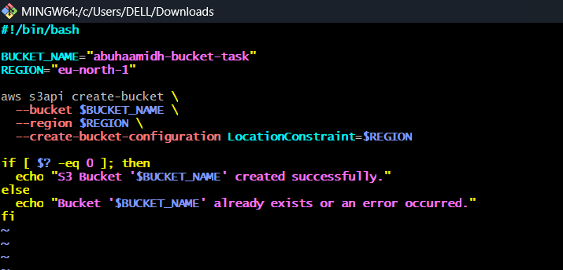
So once after the script is done, I have the permission and ran the script

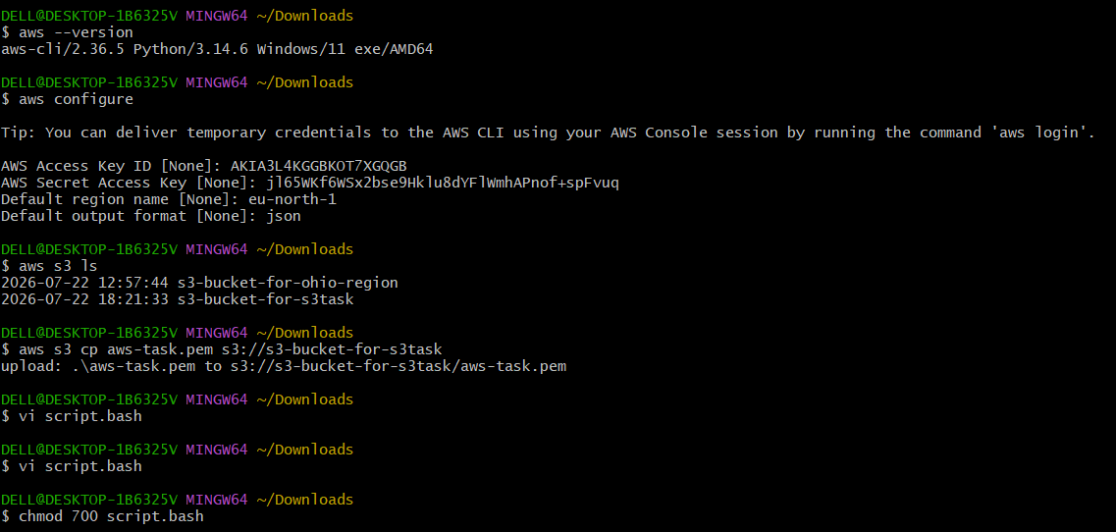
Here you can see, I just started the script with bash script.bash
It is created successfully
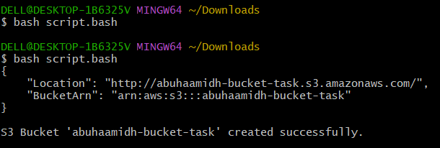
I verified it in the S3 bucket console, it is there named abuhaamidh-bucket-task
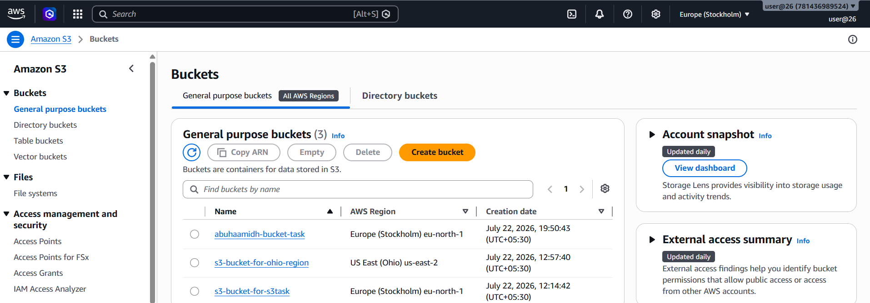

7. Upload a 1 GB file to S3 using the CLI
For this I created a file for 1GB, you can see it got created
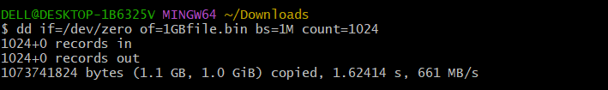
And am trying to copy it using aws cp <filename> s3:// <bucket name>
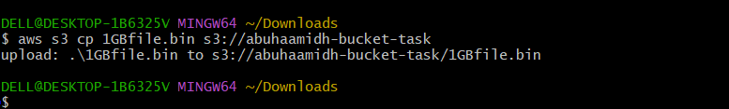
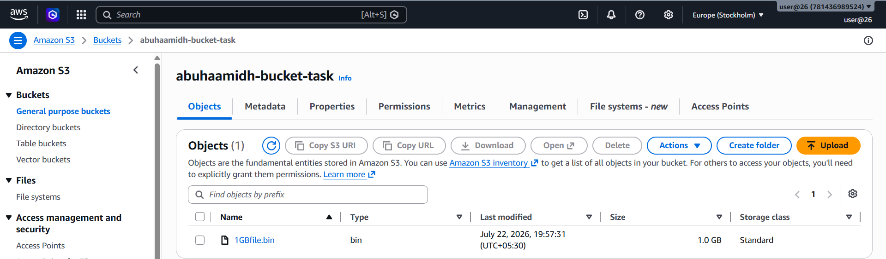
And it is uploaded, as you can see it in the s3 bucket console

